RESUME

JHANSI RANI PENNERU
GUEST FACULTY IN COMMERCE

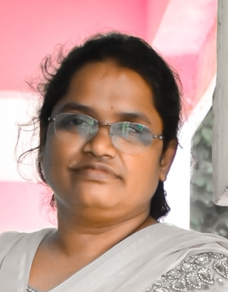
JHANSI RANI PENNERU ,
INDIRA COLONY.
MASTAN RAO ROAD,
MADHURA NAGAR,
VIJAYAWADA. Email: oct7jhansirani@gmail.com
NTR DT jhansiravisunkara@gmail.com PH: 9989906121

Seeking exposure in an organization which progresses dynamically and gives me an opportunityto improve my knowledge and enhance my skills to be a part of the
team that excels towards the growth of the organization and gives me satisfaction there of.

Academic Profile

Course | College / University | Passing of the Year
S.S.C | AMALI ENGLISH MEDIUM HIGH SCHOOL VJA, | 1993
INTER{MPC} | SARADA COLLEGE VJA | 1995
DEGREE | SATAVAHANA COLLEGE VJA | 1998
MCOM | GANDHIJI MAHILA KALASALA  ACHARAYA NAGARJUNA UNIVERSITY | 2000
MPhil | MADURAI KAMARAJ UNIVERSITY MADHURAI | 2009
NET | UGC NET QUALIFIED | 2019

SoftSkills

- M S office ,M S WORD , EXCEL
Experience: LECTURER INCOMMERCE {20 years}
- Working as lecturer in srr&cvr government college as guest faculity from 2017 november
- Lecturer in Montessori Mahila Kalasala for UG&PG from 2010 – 2017october
- Junior college Lecturer from the year 2005 - 2010
- Lecturer in Nagarjuna University Distance classes for Mcom classes &Degree classes from 2010 -2015
- Andhra Loyola College Examiner from 2012 to 2015.
- Junior Lecturer in Gandhiji Mahila Kalasala from 2000-2004,
- National Eligibilty Test Qualified - 2019 June.

- PERSONALL DETAILS:

Date of Birth:07-10-1976

Religion:HINDU

Marital Status:married

Languages Known:English, Hindi & Telugu

STRENGTHS :

- Determination & Dedication.
- Can develop interpersonal relations.
- Good independent/team work.
- Capability to work under pressure.
- Capability to work under any circumstances.
Declaration
I here by declare that the details given above are true to the best of my
Knowledge and belief

(P.Jhansi rani)

